

Republic of the Philippines
LEYTE NORMAL UNIVERSITY
College of Education
P. Paterno St. 6500

CURRICULUM VITAE

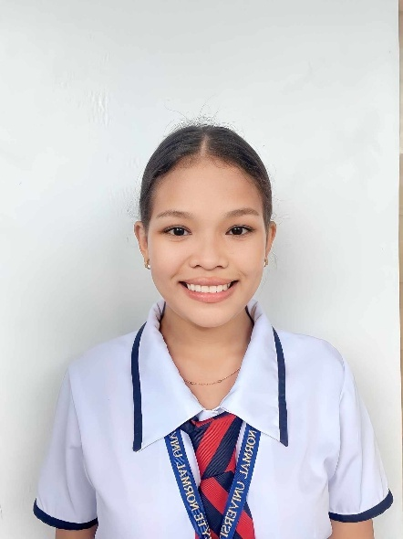
SHOVIE JANE FERNANDEZ
Channel Ridge View Blk 67 Lot 2 Brgy. District 1
Babatngon, Leyte
shoviejane.fernandez17@gmail.com
09950039383

PERSONAL PROFILE
Date of Birth : August 16, 2004
Place of Birth : Babatngon, Leyte
Citizenship : Filipino
Sex : Female
Age : 20
Civil Status : Single
Religion : Roman Catholic
Father’s Name : N/A
Mother’s Name : Josefina O. Fernandez

EDUCATIONAL ATTAINMENT
Elementary : Babatngon Central School
Rizal Avenue St. Brgy. Dist. 1 Babatngon, Leyte
2009-2016

Junior High School : Saint Vincent Ferrer Academy (SVFA), Inc.
Sto. Niño St. Brgy. Dist. 1 Babatngon, Leyte
2016-2020

Senior High School : Saint Vincent Ferrer Academy (SVFA), Inc.
Sto. Niño St. Brgy. Dist. 1 Babatngon, Leyte
2020-2022

ACHIEVEMENTS & AWARDS
- Academic Excellence Awardee (Junior High School)
- Academic Excellence Awardee (Senior High School)
- Participant (1st International Undergraduate Education Research Conference |
Dec. 3, 2024)

RESEARCH & ACADEMIC PROJECTS
- Successfully conducted and defended a quantitative research study titled “Effect of Blended Learning to Academic Performance to the Selected Junior High School Students in Saint Vincent Ferrer Academy (SVFA) Inc. S.Y. 2021-2022” as a requirement for the Practical Research 2 subject in Grade 12.

A Journey of Faith, Friendship, and Family
‎
‎When I walked into college as a first-year student, everything felt uncertain. I was supposed to take Bachelor of Elementary Education that was the plan, the direction I thought my life was set on. But somehow, life redirected me to Bachelor of Special Needs Education. At first, it felt like a wrong turn, like I had stepped into a world I wasn’t ready for. I was confused, scared, and honestly questioning if I belonged there.
‎But God has a way of placing the right people in our lives at the right time. I met friends who slowly filled the empty spaces and eased the heavy questions in my heart. They made every hesitant step feel lighter. Because of them, my first year though not the one I plannedbecame a year I learned to accept change and trust the path given to me.
‎Moving into second year, more people came into my life friends who brought warmth, comfort, and laughter into my journey. They stood beside me through requirements, breakdowns, and long nights. Every time I doubted myself, they reminded me I wasn’t alone. I passed second year because of hard work, yes, but also because of the people who lifted me up when I couldn’t lift myself.
‎But beyond my friends, there was a constant source of strength, my family.They were my safe place the ones who believed in me even when I couldn’t see my own progress. Every time I felt tired, they told me to rest but never to give up. Every time I fell behind, they reminded me of how far I had already come. My mom words, my siblings’ jokes, the simple “Kaya mo ’yan”—those things kept me moving through days when quitting seemed easier. My family didn’t just support my education,they supported "me". Their sacrifices and love built the foundation that carried me through every semester.‎
‎Then came third year. This was the year that tested everything my strength, determination, patience, and even my self-worth. The major subjects felt like mountains, each one demanding more than I felt I had. There were days I cried in silence, days filled with pressure, and nights where I wondered if I was still strong enough to continue.
‎But I kept going. My friends pushed me forward. My family held me steady. And I learned something important. I am capable of surviving storms I once thought would drown me.I passed my majors not because it was easy, but because I refused to stop fighting.
‎Now here I am, standing in my fourth year.Still learning.Still growing.Still dreaming. Some nights, I look back at my journey and can’t help but feel emotional. From the unexpected beginning, to the friendships that changed me, to the challenges that strengthened me, and the unwavering love of my family all of these made me who I am now.‎
‎And today, I’m holding onto my biggest hope I will graduate in 2026. I am claiming it, praying for it, and working for it not just for myself, but for everyone who carried me through the hardest parts of this journey. For my friends who believed in me. For my family who never let me feel alone. For the version of me who once felt lost but kept walking anyway.This story my story is not perfect, but it is beautiful.It is a story of faith, courage, struggle, and love.And one day, when I finally wear that graduation gown, I know I will look back and say with full pride and gratitude.
‎“I made it and I didn’t make it alone.”
‎
‎

